**Property Details:-**

**Stay Type;- 4BHK private pool, Seaview Villa, Porvorim North Goa**

**Guest :- 2 person each room**

**Max Capacity :- 10 Person**

**Price :- Rs.11000 - 16000**

**Location :-** [**https://www.google.com/maps/place/Apartment+F102/@15.5100589,73.7715592,17z/data=!4m9!3m8!1s0x3bbfc1ba99de5c45:0xe691091bef6ce833!5m2!4m1!1i2!8m2!3d15.5100537!4d73.7741341!16s%2Fg%2F11sfpgzts2?entry=ttu&g_ep=EgoyMDI0MTEwNi4wIKXMDSoASAFQAw%3D%3D**](https://www.google.com/maps/place/Apartment+F102/@15.5100589,73.7715592,17z/data=!4m9!3m8!1s0x3bbfc1ba99de5c45:0xe691091bef6ce833!5m2!4m1!1i2!8m2!3d15.5100537!4d73.7741341!16s%2Fg%2F11sfpgzts2?entry=ttu&g_ep=EgoyMDI0MTEwNi4wIKXMDSoASAFQAw%3D%3D)

**Address:- Sun N Sand, F102 Monarch Palm, Candolim, Goa 403519**

**Amanites:-**

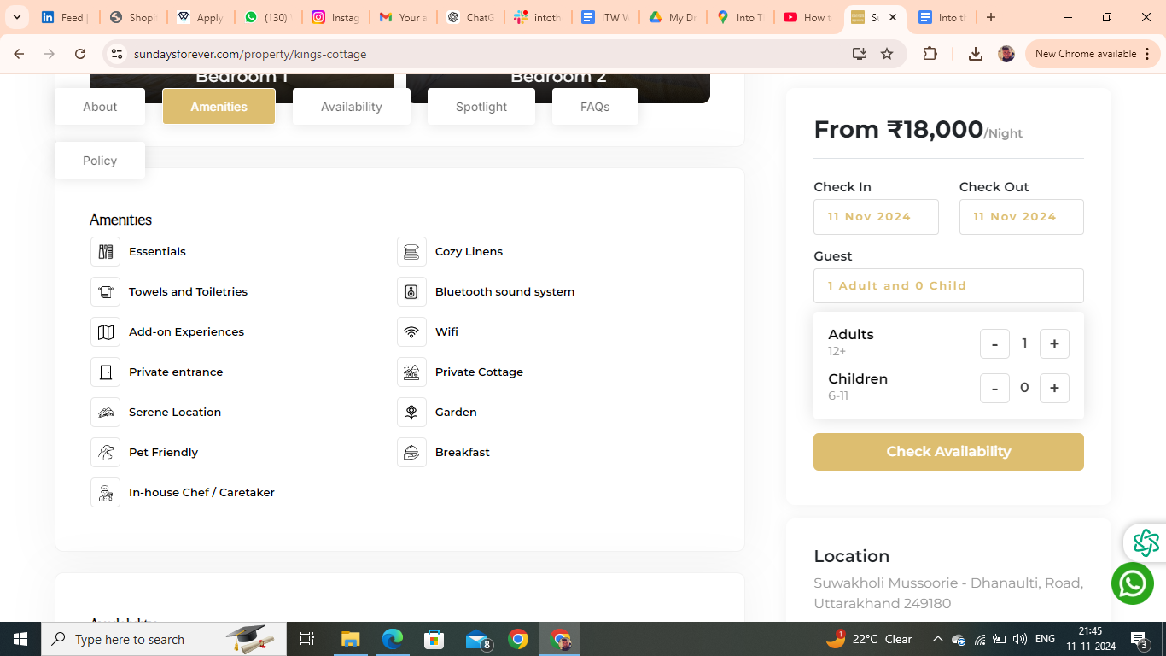

Amanites you have to remove are :- Essentials, Bluetooth Sound System, Breakfast

Add:- Swimming Pool

FAQs

## Can I book only one or two rooms, or do I need to book the entire Home?

No, you cannot book just one room. You would need to book the entire cottage.

## Is parking available onsite or nearby?

Free parking is available onsite for up to 2 cars.

**Is the Property suitable for a day picnic?**

Yes, the home has a garden/lawn area within the premises that could be used for outdoor picnic activities. Meals will be provided on site at an additional charge (per person, per meal). Please note that the maximum capacity for an overnight stay is 4 people.

**Is property pet friendly?**

We’re happy to welcome your furry friends at Villa! Please bring a pet bed along, as pets aren’t allowed on guest beds or any linen. Enjoy a comfortable stay for you and your pet in the heart of nature!

**Booking Policies**

House rules

* Check-in: 2 PM Check-out: 10 AM
* Guest are requested to shut the windows and doors during the evening . as the property may be prone to insect and bug.
* Guest are not allowed to spill food or drinks over the upholstery or they will be charged at the time of checkout.
* Please Be mindful and keep the noise to the minimum after 10 pm.
* Passport, Aadhar, Driving License and Govt. ID are accepted as ID proof(s)
* Allows private parties or events

**Refund & Rescheduling Policy**

* Refunds would be processed in 14 working days .
* Booking can be rescheduled till 15 days prior to arrival date depending upon the availability.
* Rs1000 plus applicable taxes will be charged for rescheduling .
* Rescheduling can be done only for the same property.
* If the tariff on the rescheduled date is higher than the initial booking date then the difference is payable.

**Things you need to know**

* The full payment must be made for your booking to be confirmed
* Only the guest who have been accounted for are allowed at the Property
* Any damage to the property caused by the guest will be charged as per the actual cost of repair or replacement.
* Any commercial activity is strictly not permitted.
* Guests are earnestly requested to treat the home with care.
* Any damage to the property caused by the guest will be charged as per the actual cost of repair or replacement.
* Consider this as a homestay in mountains not a Typical Hotel Stay

Cancellation and Refund Policy

* Cancellation 12 days prior to arrival date 15 % will be charged.
* Cancellation 07 days prior to arrival date 50 % will be charged.
* Cancellation less than a week full retention would be applicable.
* Credit/Debit card cancellation will be charged 5 % extra.
* Cancellation policy for long weekends and special days .
* Cancellation 07 days prior to arrival date 50 % will be charged .
* Cancellation less than a week full retention would be applicable.

**Description:-**

Welcome to Sun N Sand, a serene 4BHK villa nestled in the heart of Candolim, Goa. Perfect for families and friends, this spacious villa offers a private pool, lush garden, and stunning beach views. Experience the charm of Goa with the comfort and privacy of a home away from home. Relax, unwind, and create unforgettable memories in this idyllic coastal retreat.